FPGA-based Mental Binary Math Game User Manual

## Gokul Venugopal

## ECE 6370

# Design Description

The Game Access Control is a is a one-player game where one player sets a timer and generates a random number through toggle switches and push button. Then user has to enter a value in binary to get a sum of 15 with the random number generated. If he succeeds to do that, then he gets a score point. User can continue playing until timer reaches 0. System also provides a feature to reset timer when it reaches 0.

Number of players required: 1

Background knowledge required: 4-bit binary, 0-F Hexadecimal.

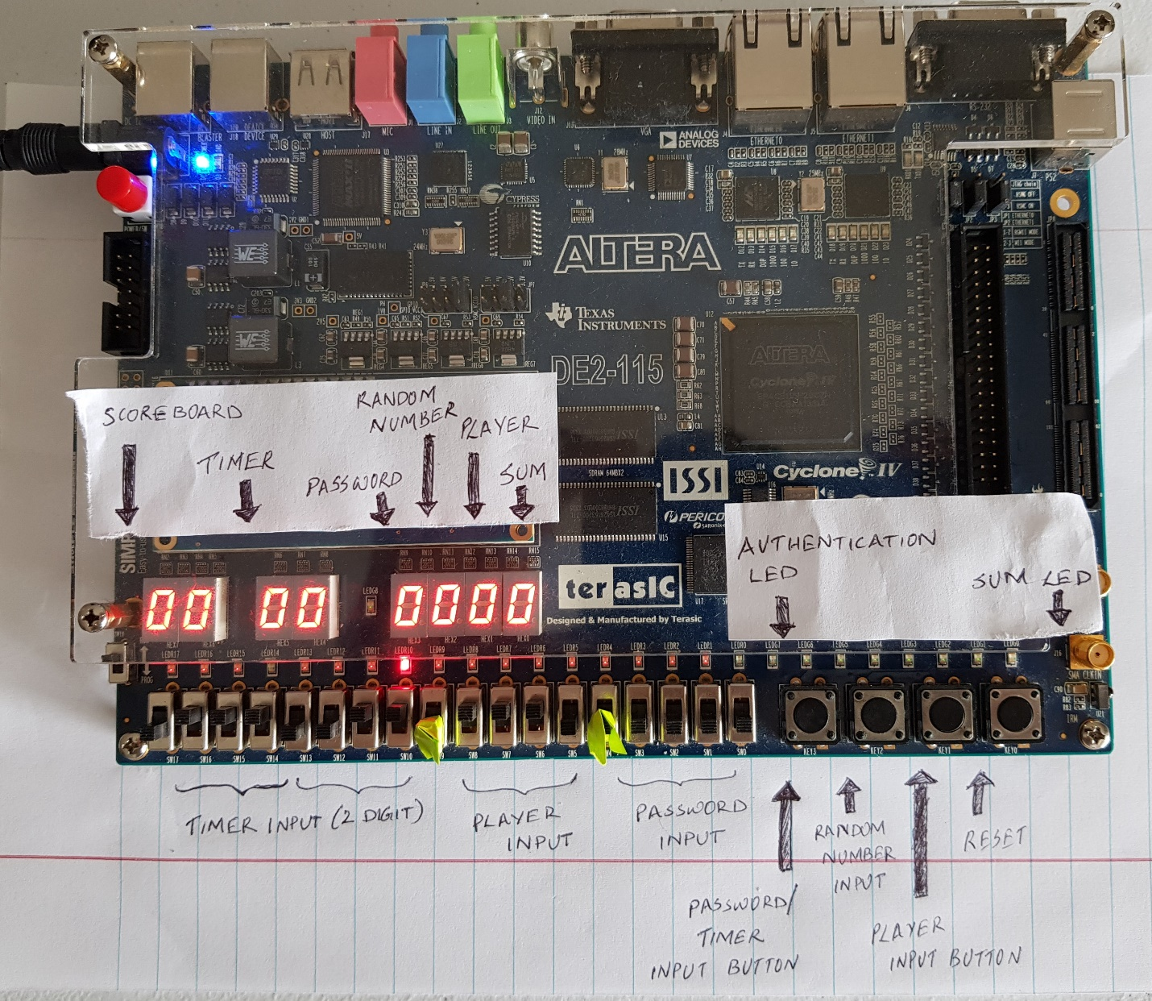**Board Overview**

Figure : Board Layout

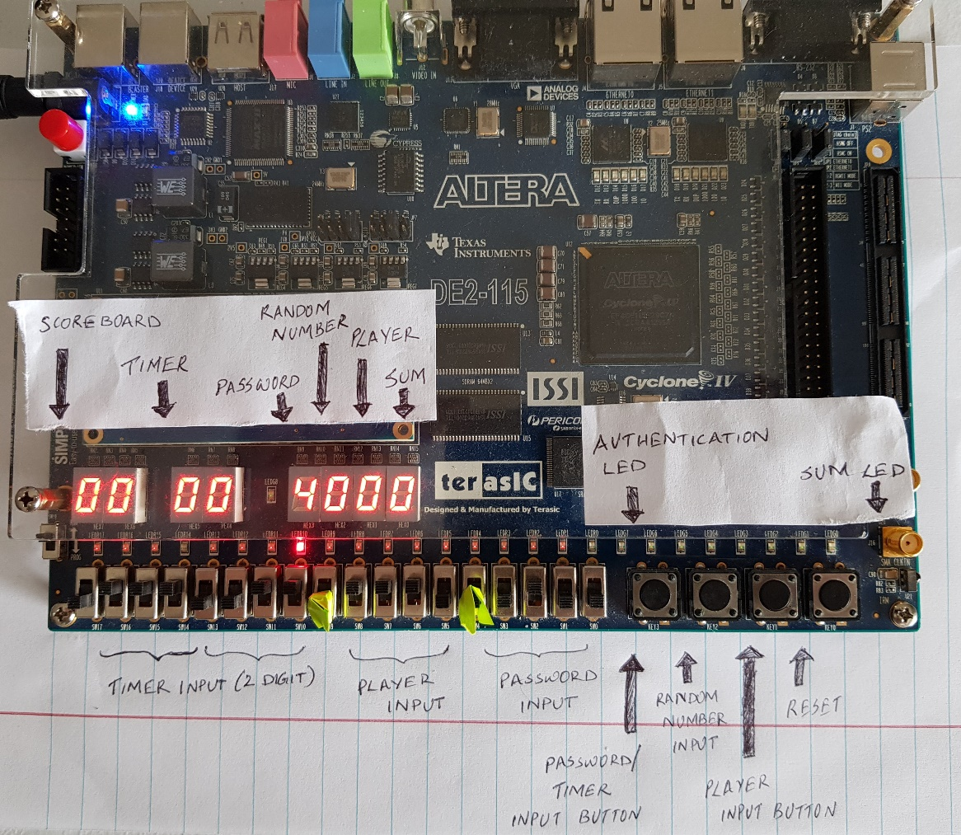

Figure : User entering password digit by digit.

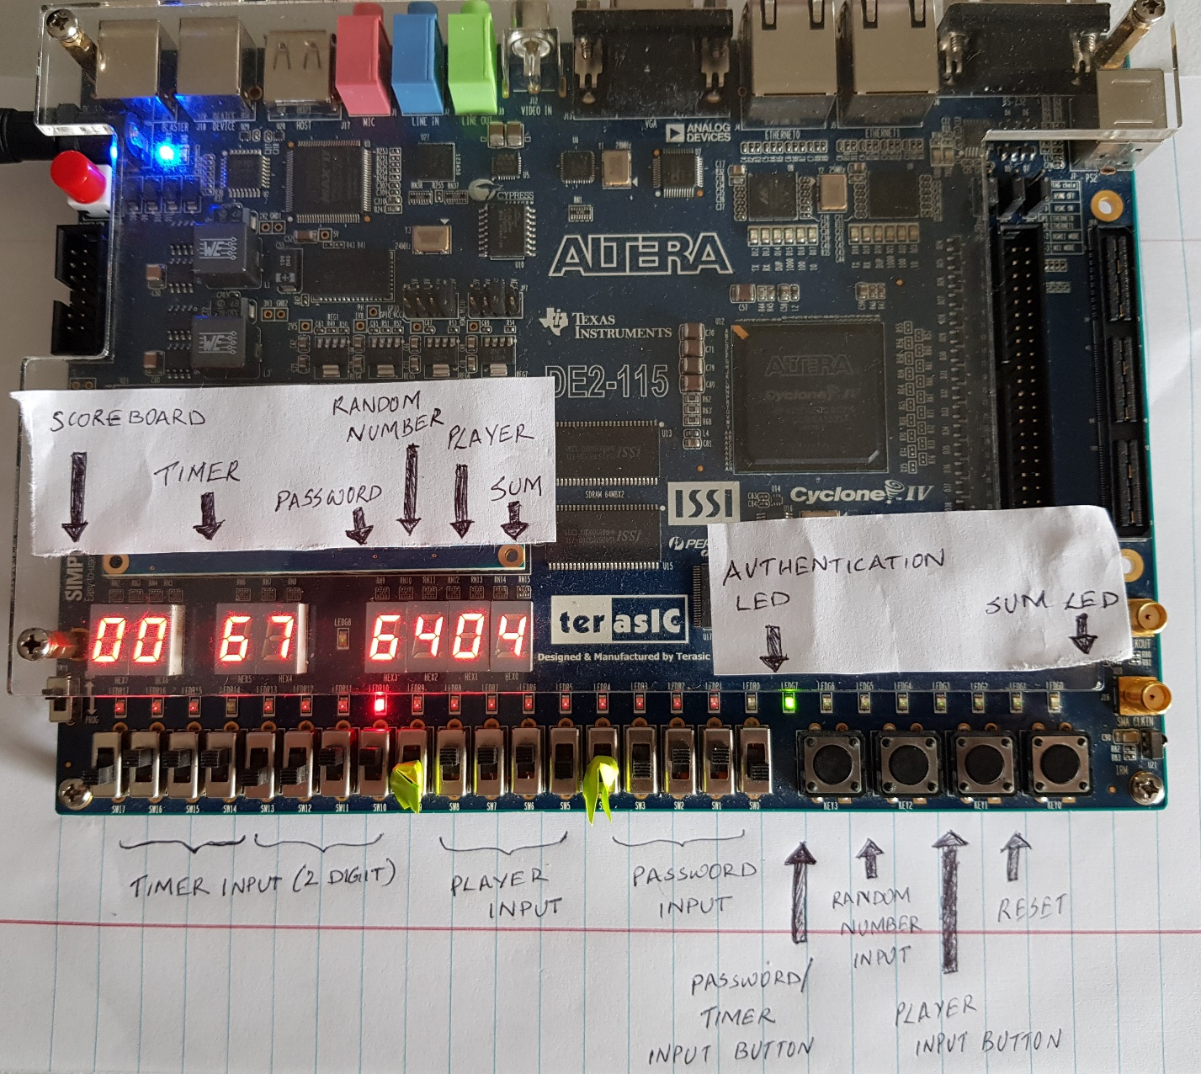

Figure : User set timer digits and hit timer button. It starts counting down per second.

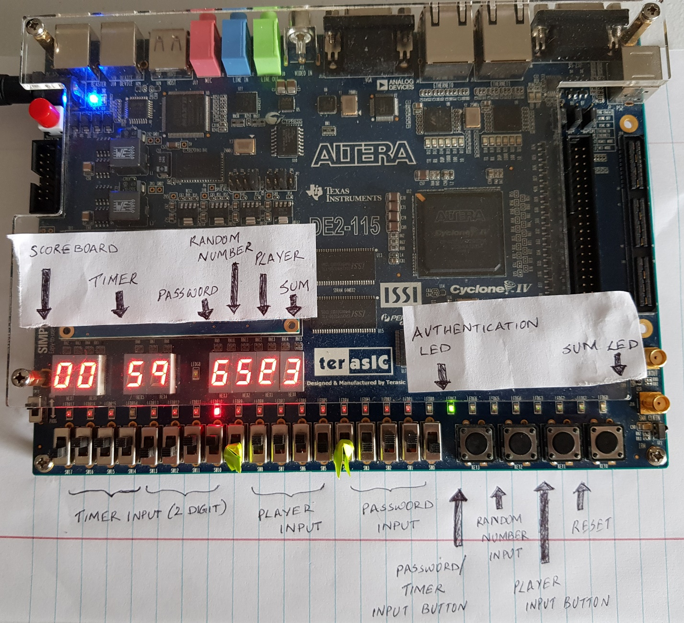

Figure : User generated a random number and input his value, but sum was not 15. It also confirmed by sum red led glowing up.

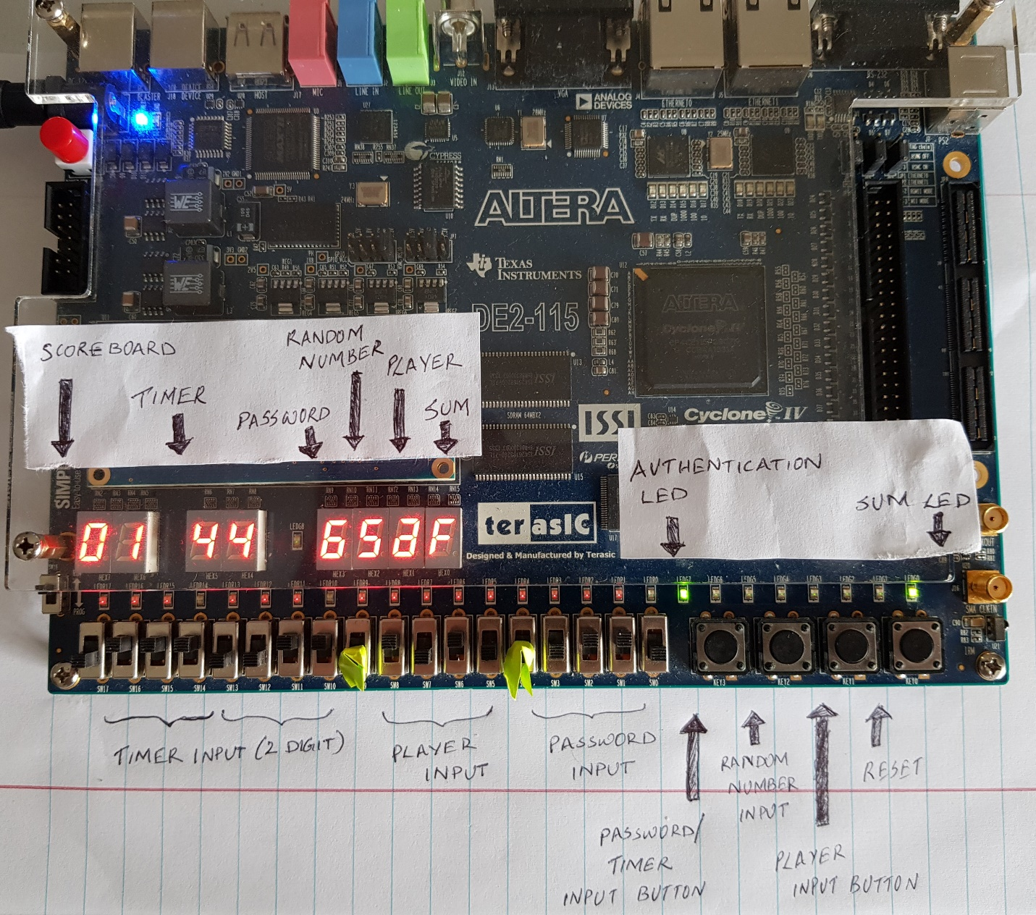

Figure : User generated another random number and entered his value to get a sum of 15. Sum green LED glows and score board increments by 1.

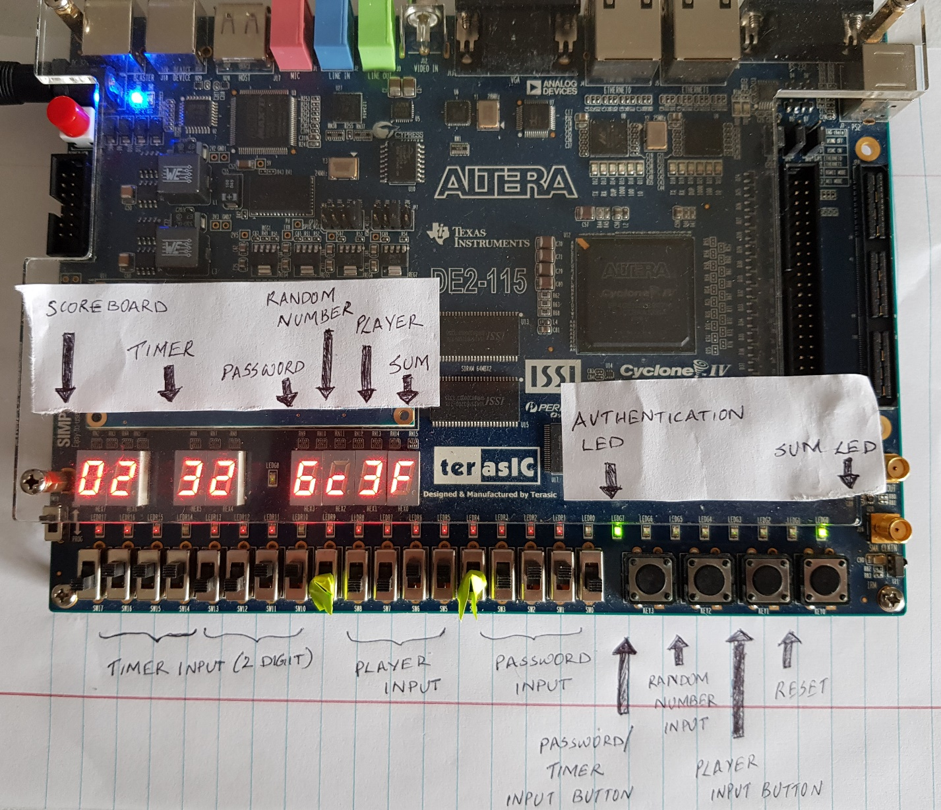

Figure : User generated another input and a random number. Score counts increases as sum is 15 shown by sum green LED.

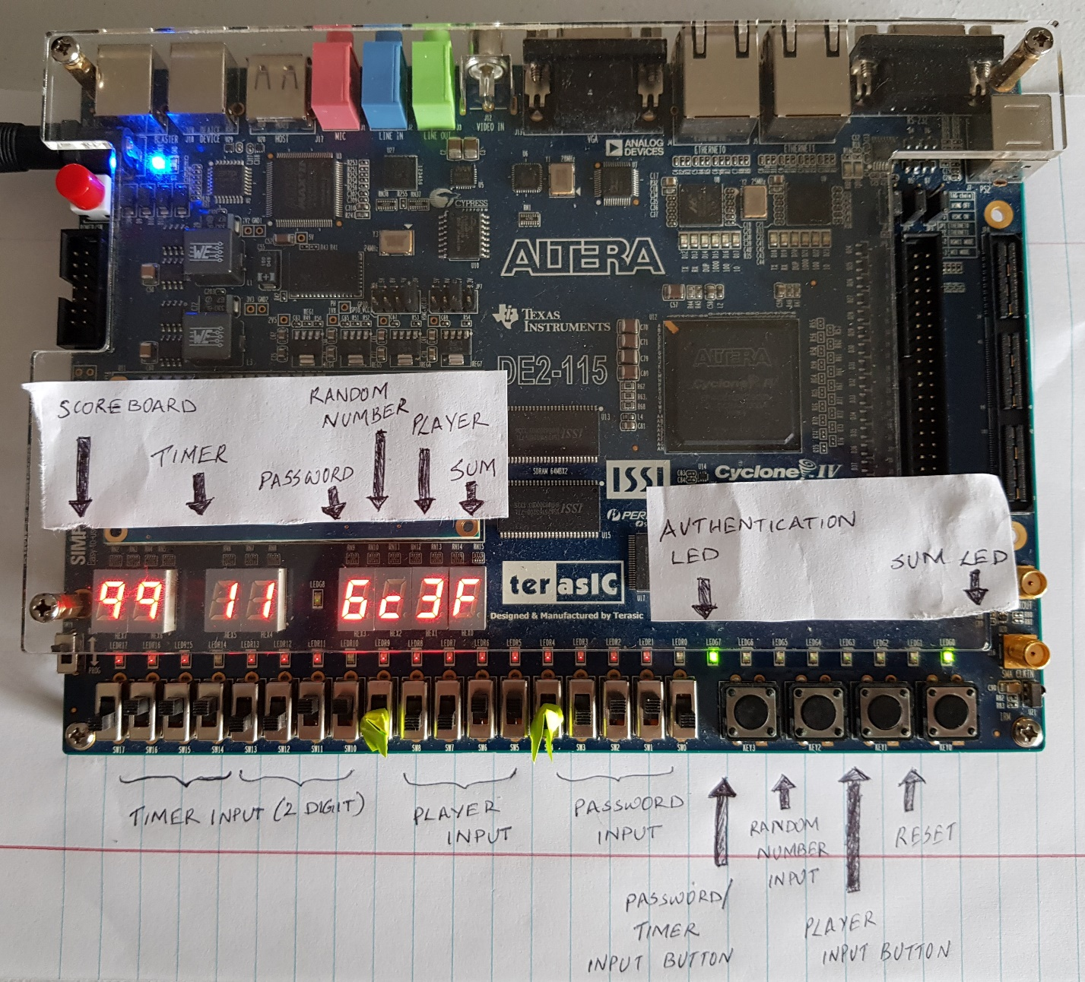

Figure : User reached maximum score of 99. After that score will be reset to 00.

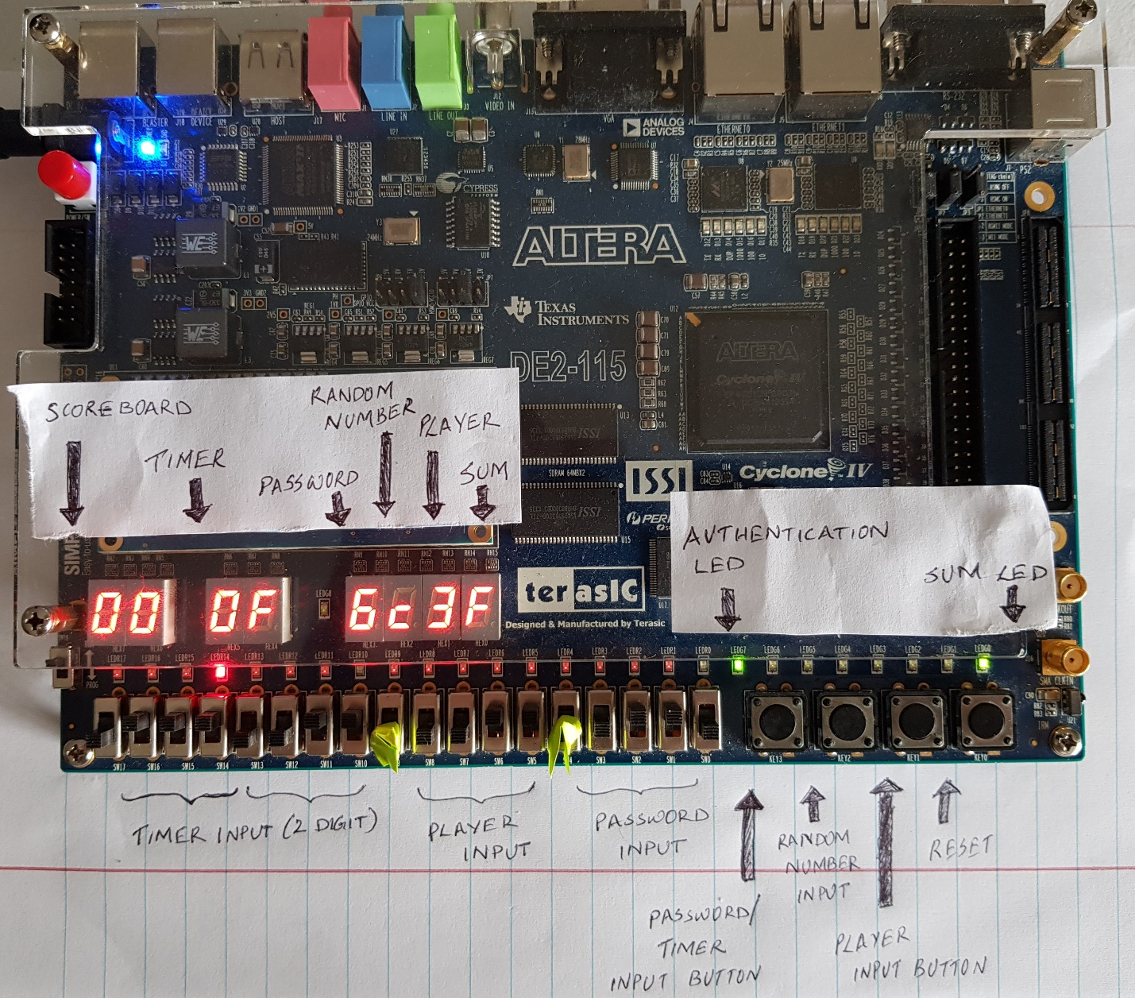

Figure : Timer reached 0 and F is displayed meaning game finished. It is also shown by timeout red LED.

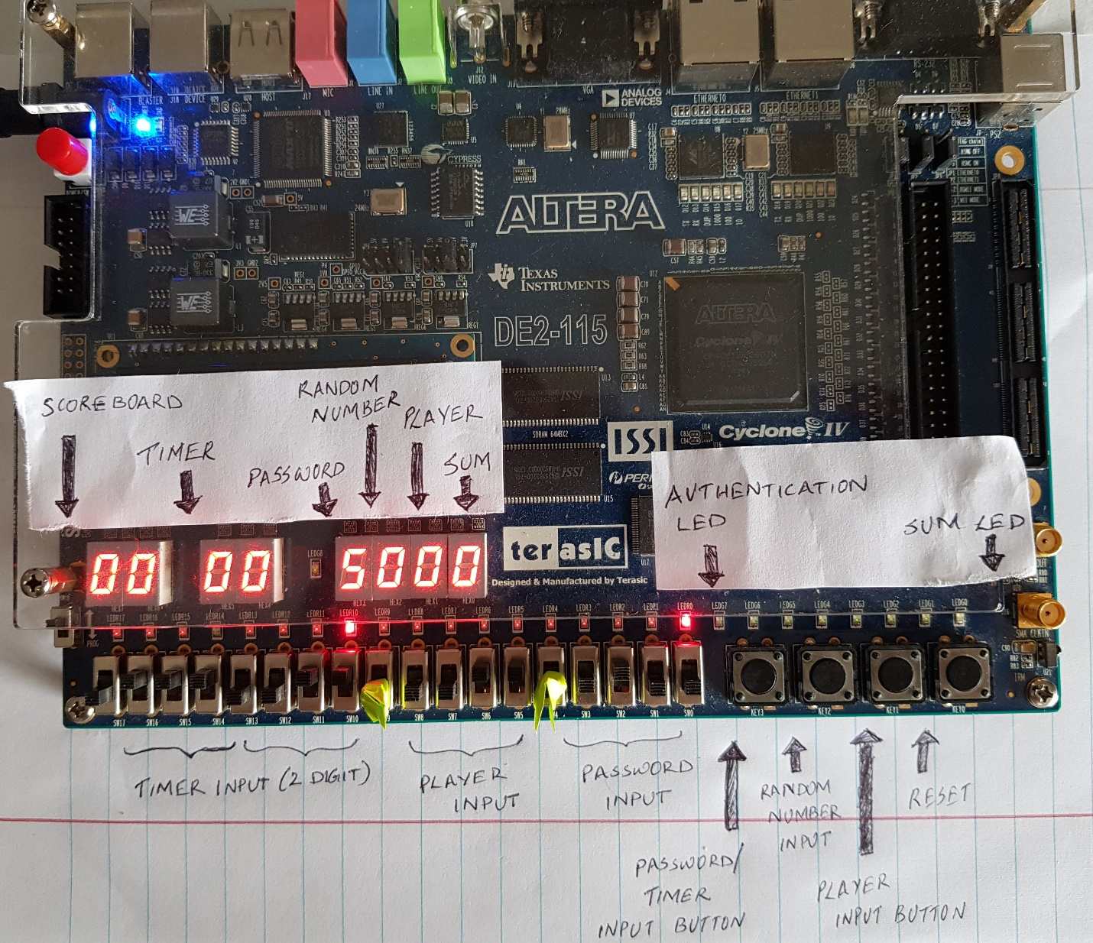

Figure : User entered wrong password. It is shown by authorization RED Led.



Figure : User hits reset button to re-enter the game.

## **Board Layout**

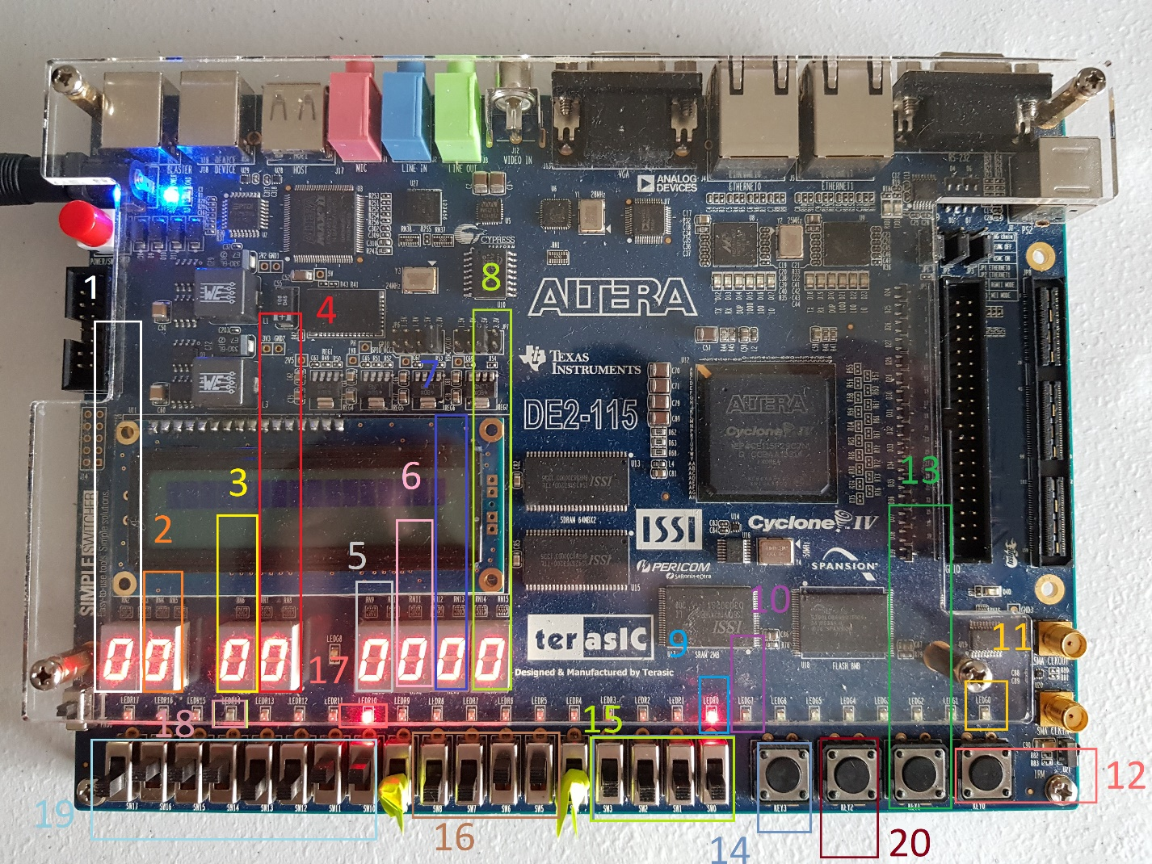

1. Score Board tens digit display
   1. Example: if a sum is 1111 and unit digit is 1001, then a 1 will display
2. Score Board unit digit display
   1. Example: if a sum is 1111, then a 1 will display
3. Timer tens digit
   1. Example: if user enter 0011 using 19, then 3 will be displayed
4. Timer unit digit
   1. Example: if user enter 0011 using 19, then 3 will be displayed
5. Password display
   1. Example: if user enter 0101 using 14, then 5 will be displayed
6. Random Number input display
   1. Example: if 13 is pressed for 4 cycles, then a 4 will display
7. Player input display
   1. Example: if an input 0100 is given by Player, then a 4 will display
8. Sum display
   1. Example: if an output 0100 is given by Sum, then a 4 will display
9. AUTHENTICATION LED – RED
   1. If user is not authenticated, then this red led glows.
10. AUTHENTICATION LED – GREEN
    1. If user is authorized, then this green led glow.
11. SUM LED – Green
    1. If sum is 1111, then this green LED glows.
12. Rst Button
    1. KEY0 – B0
    2. Example: to reset, press button.
13. Random Number Input Button
    1. KEY2 – B0
    2. Example: to input 1 value, press button.
14. Password Input Button
    1. KEY3 – B0
    2. Example: to input 1 value, press button.
15. PASSWORD TOGGLE SWITCHES
    1. SW17 – BIT3
    2. SW16 – BIT2
    3. SW15 – BIT1
    4. SW14 – BIT0
    5. Example: to input 0100 (4 in hexadecimal), pull SW17 down, push SW16 up, pull SW15 down, pull SW14 down
16. PLAYER 1 TOGGLE SWITCHES
    1. SW10 – BIT3
    2. SW9 – BIT2
    3. SW8 – BIT1
    4. SW7 – BIT0
    5. Example: to input 0100 (4 in hexadecimal), pull SW10 down, push SW9 up, pull SW8 down, pull SW7 down
17. SUM LED – Green
    1. If sum is not 1111, then this red LED glows.
18. Timeout LED
    1. If timer goes 0, this RED led glow.
19. TIMER TOGGLE SWITCHES
    1. SW17 – TENS DIGIT3
    2. SW16 – TENS DIGIT 2
    3. SW15 – TENS DIGIT 1
    4. SW14 – TENS DIGIT 0
    5. SW13 – UNIT DIGIT 3
    6. SW12 – UNIT DIGIT 2
    7. SW11 – UNIT DIGIT 1
    8. SW10 – UNIT DIGIT 0
    9. If user want to set 33, then he will push up SW15, SW14, SW11 and SW10. Then pulls down other toggle switches
20. Player Input Button
    1. KEY1 – B0
    2. Example: to input 1 value, press button.

# Authentication Instruction

1. A 4 digit password is used for authentication. Each 4 digit are given into the system in 4 bit binary form using password toggle switches(15).
2. Each digit need to be loaded in to the system using password button(14).
3. User inputs first digit using toggle switches(15) and presses button(14) to enter digit into system.
4. After inputting 4 digits, if user entered right password. GREEN LED(10) will glow.
5. Else, RED LED(9) will turn OFF.
6. To re enter into the system, player has to press rst button(12).
7. User can log in again(from Step 3).

# Timer Instruction

1. User must enter a value in seconds that is represented by two 4-digit number.
2. User need to use (19) to select a value and hit (14) to load and start the game.
3. Until timer shown in (3) and (4) reaches 0, user can generate random number and enter values.
4. When timer reaches 0, timeout signal is shown by lighting up (17) and ‘F’ is shown in (4) which means game is finished.
5. To reset timer, user must hit timer button (14) twice. When user hits first, system will show the value of timer in (3) and (4). When user hits again, it starts counting down.
6. User can do this as much as he wants.
7. User cannot reset the timer when it is running. He can only reset timer if it has reached 0 or user presses reset button(in this case, user has to first get authenticated).

# Score Board Instruction

1. When timer (3) & (4) is running, user can generate a random number using (20) and enter his value using (20) to get a sum of 15 shown using (8).
2. If sum (8) is F, then (2) increases from 0 to 9. Once (2) reaches 9 it will reset to 0 and increases (1) by 1.
3. Step 2 continues until (1) & (2) reaches 99. After that (1) & (2) resets to 0.

# Random Number Generation Instruction

1. User can generate a random number shown in (6) any number of times as long as timer (3) & (4) is not 00.
2. To generate a value, user needs to press (20) and value will be shown in (6) once user releases (20). The value will be equal to the time user has kept it down.
3. If user is not authorized and timer is not set, then user can not generate random number.

# Example Rounds

Failed Round 1:

1. User inputs 1234 as password(15) one by one with (14) being pressed for each digit.
2. Each digit is displayed in (5).
3. Access is Denied. Authentication RED LED (9) will glow.

Failed Round 2:

1. User enter right password with switches(15) one by one with (14) being pressed for each digit.
2. Access is Granted. Authentication GREEN LED(10) will glow.
3. Player sets timer using switches(19) and then presses button(14) to start game.
4. Player generates a random number using (20). Assume that value to be 1100.
5. A C will display on Random number display(6)
6. Player inputs 0010 using (15)
7. A 2 will display on Player’s display(7)
8. An E will display on the SUM display(8)
9. The red LED(9) will light up
10. Player did not successfully enter a number that added with random number to get F.

Successful Round:

1. User enter right password with switches(15) one by one with (14) being pressed for each digit.
2. Access is Granted. Authentication GREEN LED(10) will glow.
3. Player sets timer using switches(19) and then presses button(14) to start game.
4. Player generates a random number using (20). Assume that value to be 1100.
5. A C will display on Random number display(6)
6. Player inputs 0011 using (15)
7. A 3 will display on Player’s display(7)
8. An F will display on the SUM display(8)
9. The green LED(10) will light up.
10. A 1 will be displayed in 2.
11. Player successfully enter a number that added with random number to F.
12. User press password button(4) to log out.
13. Authentication GREEN LED(9) will turn OFF.
14. User can repeat from step 4. Until timer reaches 0 which will be displayed in 3 and 4.
15. Once timer reaches 0

Good Luck!